The Nautilus DevOps team needs a new private RDS instance for their application. They need to set up a MySQL database and ensure that their existing EC2 instance can connect to it. This will help in managing their database needs efficiently and securely.
1) Task Details:
- Create a private RDS instance named xfusion-rds using a sandbox template.
- The engine type must be MySQL v8.4.5, and it must be a db.t3.micro type instance.
- The master username must be xfusion_admin with an appropriate password.
- The RDS storage type must be gp2, and the storage size must be 5GiB.
- Create a database named xfusion_db.
- Keep the rest of the configurations as default. Ensure the instance is in available state.
- Adjust the security groups so that the xfusion-ec2 instance can connect to the RDS on port 3306 and also open port 80 for the instance.
2) An EC2 instance named xfusion-ec2 exists. Connect to this instance from the AWS console. Create an SSH key (/root/.ssh/id_rsa) on the aws-client host if it doesn't already exist. Add the public key to the authorized keys of the root user on the EC2 instance for password-less SSH access.
3) There is a file named index.php under the /root directory on the aws-client host. Copy this file to the xfusion-ec2 instance under the /var/www/html/ directory. Make the appropriate changes in the file to connect to the RDS.
4) You should see a Connected successfully message in the browser once you access the instance using the public IP.

Use the below given AWS Credentials: (You can run the showcreds command on the aws-client host to retrieve these credentials)
Console URL | https://084713293409.signin.aws.amazon.com/console?region=us-east-1
Username | kk_labs_user_998511
Password | TT2qW8@oKj5Q
Start Time | Wed Dec 31 06:38:06 UTC 2025
End Time | Wed Dec 31 07:38:06 UTC 2025
Notes:
- Create the resources only in the us-east-1 region.
- To display or hide the terminal of the AWS client machine, you can use the expand toggle button as shown below:
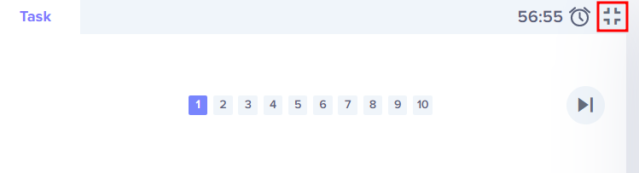

Solutions:-
Solution
Step 1: Set Variables
RDS_NAME="nautilus-rds"
ENGINE="mysql"
ENGINE_VERSION="8.4.5"
DB_INSTANCE_TYPE="db.t3.micro"
DB_STORAGE=5
DB_STORAGE_TYPE="gp2"
DB_USER="nautilus_admin"
DB_NAME="nautilus_db"
DB_SUBNET_GROUP="db-subnet-group"
RDS_SECURITY_GROUP="rds-sg"
EC2_NAME="nautilus-ec2"
Step 2: Get Default VPC & Subnets
VPC_ID=$(aws ec2 describe-vpcs \
--filters Name=isDefault,Values=true \
--query "Vpcs[0].VpcId" \
--output text)
Get subnet IDs
SUBNET_IDS=$(aws ec2 describe-subnets \
--filters Name=vpc-id,Values="$VPC_ID" \
--query "Subnets[*].SubnetId" \
--output text)
Create DB Subnet Group
aws rds create-db-subnet-group \
--db-subnet-group-name $DB_SUBNET_GROUP \
--db-subnet-group-description "Nautilus RDS subnet group" \
--subnet-ids $SUBNET_IDS
Step 3: Create Security Group for RDS
RDS_SG_ID=$(aws ec2 create-security-group \
--group-name $RDS_SECURITY_GROUP \
--description "RDS access from ec2 instance" \
--vpc-id "$VPC_ID" \
--query "GroupId" \
--output text)
Step 4: Create RDS Instance
aws rds create-db-instance \
--db-instance-identifier $RDS_NAME \
--engine $ENGINE \
--engine-version $ENGINE_VERSION \
--db-instance-class $DB_INSTANCE_TYPE \
--allocated-storage $DB_STORAGE \
--storage-type $DB_STORAGE_TYPE \
--master-username $DB_USER \
--master-user-password AdminPa55 \
--db-name $DB_NAME \
--db-subnet-group-name $DB_SUBNET_GROUP \
--vpc-security-group-ids "$RDS_SG_ID" \
--no-publicly-accessible
Wait until available
aws rds wait db-instance-available \
--db-instance-identifier $RDS_NAME
Step 5: Configure Security Groups
Allow MySQL (3306) from EC2 Get EC2 security group
EC2_ID=$(aws ec2 describe-instances \
--filters Name=tag:Name,Values=$EC2_NAME \
--query "Reservations[0].Instances[0].InstanceId" \
--output text)

EC2_SG_ID=$(aws ec2 describe-instances \
--instance-ids "$EC2_ID" \
--query "Reservations[0].Instances[0].SecurityGroups[0].GroupId" \
--output text)
Allow EC2 → RDS
aws ec2 authorize-security-group-ingress \
--group-id "$RDS_SG_ID" \
--protocol tcp \
--port 3306 \
--source-group "$EC2_SG_ID"
Open HTTP (80) on EC2
aws ec2 authorize-security-group-ingress \
--group-id "$EC2_SG_ID" \
--protocol tcp \
--port 80 \
--cidr 0.0.0.0/0
Add an inbound rule to allow SSH (port 22)
aws ec2 authorize-security-group-ingress \
--group-id "$EC2_SG_ID" \
--protocol tcp \
--port 22 \
--cidr "0.0.0.0/0"
Step 6: SSH Key Setup (we'll be doing this part from AWS management console)
Create SSH Key on AWS client host
ssh-keygen
Copy the public key
cat /root/.ssh/id_rsa.pub
From the AWS management console
- Connect to the EC2 instance using EC2 Instance Connect
Note: Make sure SSH access is allowed by the EC2 security group.
- On the EC2 instance switch to root user:
sudo su -
- Add the public key copied earlier from aws-client to /root/.ssh/authorized_keys file on the EC2 instance
- After adding the public key you should be able to SSH to the EC2 instance as root user.
Step 7: Copy PHP File & Configure DB Connection
From AWS client host: Get RDS endpoint
RDS_ENDPOINT=$(aws rds describe-db-instances \
--db-instance-identifier $RDS_NAME \
--query "DBInstances[0].Endpoint.Address" \
--output text)

echo "RDS endpoint: $RDS_ENDPOINT"
Replace the placeholders with the actual RDS values
<dbname> → nautilus_db
<dbuser> → nautilus_admin
<dbpass> → AdminPa55
<dbhost> → <RDS_ENDPOINT>
Copy index.php file to EC2 instance
scp /root/index.php root@<VM_PUBLIC_IP>:/var/www/html/index.php
Step 8: Update configuration files on EC2 instance
SSH to the instance from the AWS client host
ssh root@<VM_PUBLIC_IP>
Note: For this task apache2 is running on a ubuntu instance, if the setup is different update the configuration files accordingly.
Update /etc/apache2/mods-enabled/dir.conf to serve index.php
- index.php should be before index.html
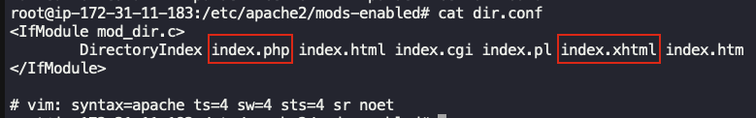
OR
Delete the index.html file from /var/www/html/ location on the EC2 instance
Step 9: Verification
Access the EC2 instance with its public IP from a web browser of your choice.
You should Connected successfully message.
